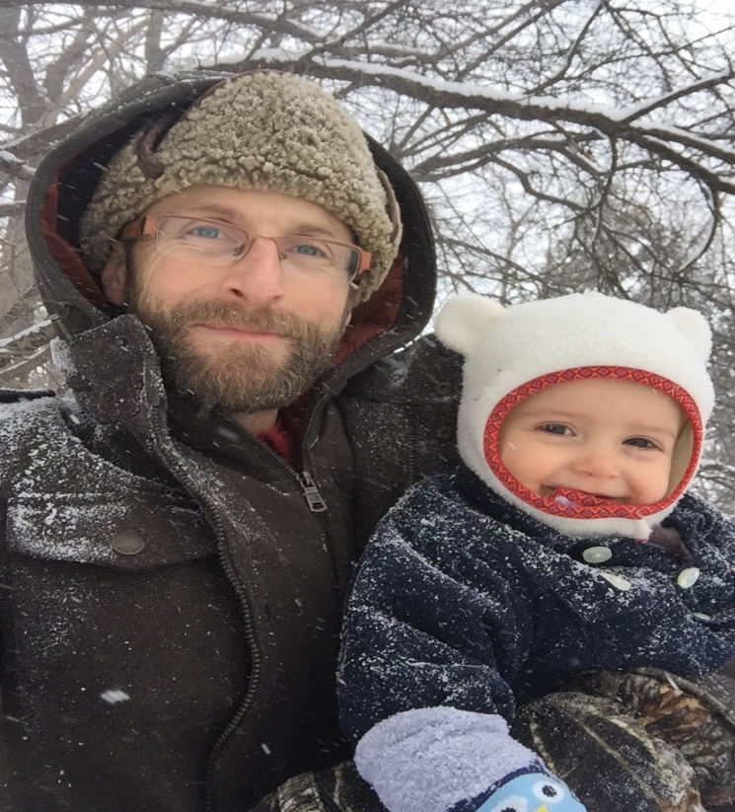

Keep Your Family
Healthy This Winter!
Do It Yourself
Home Medicine Cabinet

Stock your own home medicine cabinet with

Dr. Richard Vuksinic ND.

Tuesday October 24th from 7:30 to 8:30pm

Join Dr. V. as he discusses strategies for keeping healthy during the winter months. Dr. V. will explore immune support using nutrition and supplements. He will also focus on anti-viral, and anti-bacterial herbal medicines appropriate for your home medicine cabinet.

